Project planning Phase
Project Planing Template (Product Backlog, Sprint Planning, Stories, Story points)
Date 08.03.2026
Team ID SWTID-2026-7798
Project Name Spendwise

Product Backlog, Sprint Schedule, And Estimation
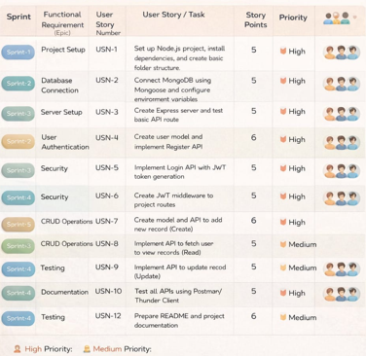

Project Tracker, Velocity & Burndown Chart
